Project Report Format
- INTRODUCTION

  - Project Overview :The Smart Library Request Workflow is a digital solution developed using ServiceNow to automate the traditional library system. It allows students to request books online and enables librarians to manage approvals efficiently. The system tracks book availability, request status, and ensures smooth communication between users.

  - Purpose
• To automate manual library processes
• To reduce delays in book request approvals
• To improve transparency and tracking
• To enhance user experience for students and librarians

- IDEATION PHASE

  - Problem Statement : The existing library system relies on manual processes, which leads to delays, lack of tracking, and inefficiency in managing book requests and approvals.

  - Empathy Map Canvas
Users: Students & Librarians
- Says: “I need books quickly”, “Approval takes time”
- Thinks: “There should be an easier system”
- Does: Visits library, fills manual forms
- Feels: Frustrated due to delays and lack of updates

  - Brainstorming
• Online book request system
• Automated approval workflow
• Real-time status updates
• Email notifications
• Reports for analysis

- REQUIREMENT ANALYSIS
  - Customer Journey map
• Student logs into system
• Searches for available books
• Submits request
• Librarian reviews request
• Approves or rejects, Book status updated

  - Solution Requirement
Functional Requirements:
- Book request submission
- Approval/rejection system
- Status tracking
- Notification system

Non-Functional Requirements:
- User-friendly interface
- Fast processing
- Secure system

  - Data Flow
- Student → Request Form → System
- System → Librarian → Approval
- System → Database → Status Update

  - Technology Stack
• Platform: ServiceNow
• Tools: Flow Designer, UI Policies, ACLs
• Database: ServiceNow Tables

- PROJECT DESIGN
  - Problem Solution Fit: The solution effectively solves inefficiencies in manual systems by automating workflows, improving tracking, and enhancing communication between users.

  - Proposed Solution
• Students to request books online
• Librarians to approve or reject requests
• Automatic updates of book status
• Notifications for users
• Reporting and analytics

  - Solution Architecture
- Roles: Student, Librarian
- Tables: Book, Borrow Request
- Reference qualifier: Ensures only available books can be requested
- Flow Designer: Automates approval and updates status to Issued
- UI Policies: Lock fields after approval
- ACLs: Enforce role-based access
- Reports: Most Borrowed Books

- PROJECT PLANNING & SCHEDULING
  - Project Planning
• Week 1: Requirement Analysis
• Week 2: Design Phase
• Week 3: Development (Tables & Forms)
• Week 4: Workflow Automation
• Week 5: Testing
• Week 6: Final Implementation

- FUNCTIONAL AND PERFORMANCE TESTING
  - Performance Testing
• Tested system response time
• Verified request submission process
• Checked approval workflow
• Ensured accurate status updates
• Tested multiple user access

- RESULTS
  - Output Screenshots
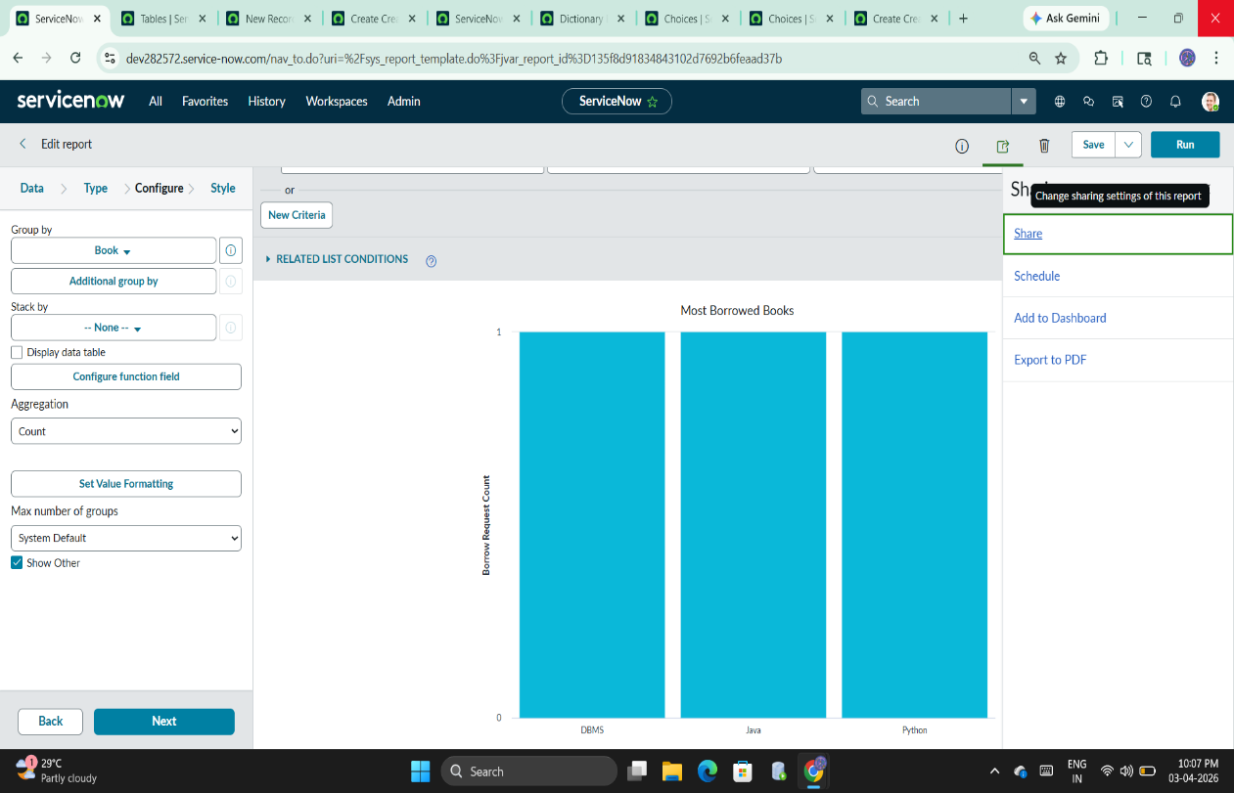

- ADVANTAGES & DISADVANTAGES
Advantages
- Saves time
- Reduces manual errors
- Improves transparency
- Easy tracking
Disadvantages
- Requires internet access
- Initial setup effort
- Requires basic training

- CONCLUSION
The Smart Library Request Workflow successfully automates the traditional library system, improving efficiency, accuracy, and user satisfaction.

- FUTURE SCOPE
  - Mobile application integration
  - AI-based recommendations
  - RFID tracking system
  - Advanced analytics dashboard

11. APPENDIX
Source Code(if any)
Dataset Link
GitHub & Project Demo Link

